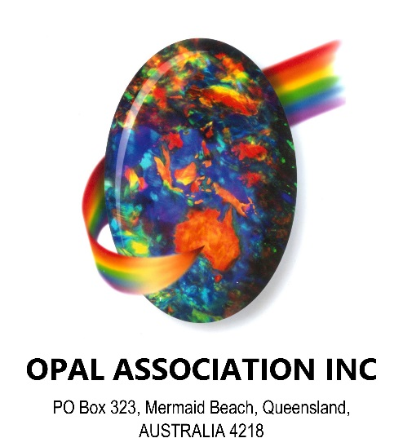

Hon. Daniel [Van Holst Pellekaan](https://www2.parliament.sa.gov.au/Internet/DesktopModules/MemberDrill.aspx?PId=4342)

Minister for the Department of Energy and Mining

Government of South Australia

GPO Box 320

Adelaide SA 5001

18th October 2018.

Dear Sir,

Re: Submissions for the Future of Opal Mining at Mintabie

Our Association represents participants in the opal industry including miners, cutters, processors, manufacturers, dealers, exporters and retailers.

The call for submissions in relation to the future of opal mining in Mintabie was brought to our attention by a third party on 24th September 2018. We notice that the date for submissions closes on 31st October 2018. We have very strong views about this issue but as you might appreciate there has been little time for us to read the report by the review panel and prepare this response.

Here is an outline of our views on the proposed closure of Mintabie:

1. The Opal Association (OA) understands that the decision to close Mintabie is based upon a finding which found anti-social and illegal behaviours in the area. These behaviours are criminal matters which need to be dealt with by the Police.
2. We also understand that the opal mining community is not implicated in these activities and that the culprits are generally known to be mostly from out of town. This being the case it seems unfair that a viable opal mining industry in Mintabie could be closed down.
3. The Australian Opal Industry (AOI) is currently rejuvenating and experiencing strong demand, particularly from the most important fashion jewellery houses in the world. Mintabie opal has been highly sought after by the gem and jewellery trade and will enjoy the rewards of this resurgence.
4. OA is aware of some very successful and exciting opal prospecting work going on in Mintabie by resourceful and committed opal miners. We believe that the ongoing potential for strong yields from opal mining in Mintabie should be encouraged and preserved.
5. A recent report to the SA Department of the Premier and Cabinet by Laszlo Katona Principal Geoscientist, Geological Survey of SA estimates that the potential opal resource in Mintabie, is estimated to have a value of over $3.6 billion in raw product.
6. The Australian gem industry is at the forefront of efforts to bring responsible and sustainable practices to the gemstone industry worldwide. Australian Opal Mining which is heavily regulated and generally compliant is an exemplar of these practices and is seen as a model of excellence which has been studied closely by opal mining bodies in Mexico and Ethiopia.
7. There is a high level of compliance by opal miners in Mintabie. The Department of the Premier and Cabinet Opal Program conducted 69 inspections of opal mining leases in Mintabie during 2016-2017. There were 8 letters issued for non-compliance and all complied with the requests. There has been no miners taken to court for breach of the opal mining act or regulations.
8. For around 140 years opal mining has been conducted by small artisanal miners and small enterprises. This is due to the nature of opal formation and the sporadic occurrence of the discoveries. We anticipate that opal prospecting and mining can continue well into the future, providing there is appropriate access to the opal bearing deposits of the Great Artesian Basin.
9. The AOI has worked closely and harmoniously with traditional owners in many locations around Australia including the APY community in Mintabie.
10. The successful working arrangements with the traditional owners of the land surrounding opal mining communities have been both informal and formal through the use of ILUA and Native Title agreements.
11. Trust in our amazing national gemstone is growing and will continue to grow dramatically. It is one of the few gemstones produced which is not treated or enhanced. It is gaining recognition as one of the most ethically mined gemstones in the world. The AOI is looking at ways of leveraging from our position of being a responsibly sourced and sustainably mined gemstone.
12. OA estimates that around 30 years ago, Australia exported opal with a value of $500 million today we estimate that number to be around $300 million. The potential to grow this industry is only limited by the restrictions of governments and the resulting lack of willingness by resourceful miners.
13. The Australian Opal Centre which is planned for Lightning Ridge NSW is estimated by the NSW Department of Planning to generate an extra $49M per annum for the NSW economy alone. This information warrants some further investigations for the tourism potential of Mintabie and the other SA opal fields.
14. With growing awareness of opal and increasing tourism to Australia and within Australia, this product can grow well beyond former export achievements.
15. The industry is planning to relaunch The Australian Gemstone Industry Council, previously formed under the Australian Minerals and Energy Council. This body will ensure close and regular communication with government departments is maintained.
16. National and International scientists are keen to set up and contribute to a scientific hub based in Australia to better understand the genesis and formation of opal. This will help our opal miners prospect for opal with greater confidence and produce more opal for a hungry consuming market.
17. With the prospect of new opal finds, comes the need for enterprising individuals to take up opal mining. OA estimates that the current average age of opal miners in Australia is over 65. We believe that this industry provides tremendous employment and business opportunities for people looking to work and provide a living for themselves and their families.
18. A successful opal mining industry also fits well with the desire to decentralize from the major capital cities and provide better support, infrastructure and opportunities for populations living in remote areas.
19. Our Association expects that many International Gem Trade and Jewellery Associations would get behind our endeavours to save and protect the livelihoods of opal miners in Mintabie and continue the production of a beautiful and highly sought after natural resource.

The Opal Association of Australia recommends that you allow opal mining to continue at the Mintabie Precious Stones Field (MPSF) and that you provide assistance so that the tremendous potential of the opal resource can be realised for the great benefit of all Australians well into the future. OA welcomes the opportunity to provide assistance with any further information, research and assistance you may require. Please feel free to contact the writer Paul Sedawie [sedaopals@hotmail.com](mailto:sedaopals@hotmail.com), or Damien Cody [damien@codyopal.com](mailto:damien@codyopal.com) .

Yours faithfully,

Paul Sedawie

President

Copies sent to:

Federal Minister for Resources and Northern Australia. The Hon. Matthew Canavan

Federal Member for Grey. The Hon. Rowan Ramsay

State Member for Giles. The Hon. Edward Hughes